SPOKANE HISTORIC LANDMARKS COMMISSION

Wednesday, January 15, 2020

Meeting Minutes:

Meeting called to order at 3:00 pm by Jacque West

Attendance
- Commission Members Present: Betsy Bradley, Amanda Paulson, Jodi Kittel, Austin Dickey, Ernie Robeson, Sylvia Tarman, Jacque West, Ray Rast
- Commission Members Not Present:
- Staff Present: Megan Duvall, Logan Camporeale, Stephanie Bishop

Changes to Agenda
- The Webster Building nomination was moved from this agenda to the February agenda.

Hearings

1. Review for Spokane Register Application: Inland Auto Freight Building – 102 E Main Avenue:
- Staff Report: Megan Duvall, Historic Preservation
- Committee Report: Betsy Bradley
- Applicant Report: Jimmy King (Building Owner)
- Questions asked and answered

Public Testimony: None

Ray Rast moved, based on Findings of Fact, that the Inland Auto Freight Building at 102 East Main Avenue is eligible under Category A, and recommended for approval by the City Council to be placed on the Spokane Register of Historic Places. Betsy Bradley seconded; motion carried.

Public Hearing adjourned at 3:16 pm.

Briefing Session: Meeting called to order at 3:16 pm by Jacque West

December 18, 2019 Meeting Minutes approved unanimously.

- Old Business:
- Megan Duvall gave an update on 2020 commissioners. Betsy Bradley and Jodi Kittel are up for reappointment on February 3, and Betsy will take on the role of Historian. The Mayor’s Office sent six applications for the current openings, but we didn’t receive any for Construction Specialist. Megan talked to the County about Ernie Robeson moving into the Construction Specialist, so we can open the County At-Large position. It will go in front of the County Board of Commissioners for approval.
- Logan Camporeale shared an Inlander article on The Forest Commune, a property just outside the Browne’s Addition Historic District.
- New Business:
- Megan advised she’s received three nominations for the February 19th meeting: Edwidge Apartments, Myrtle Apartments, and Wells Chevrolet Building, and the fourth nomination for the February meeting will be the Webster Building that was moved forward from today’s meeting.
- Megan gave an update on the Paulson Building’s window replacement project and commission members discussed the project.
- Logan gave an overview of the Cannon Historic District nomination process and hopes to have a rough draft nomination for commission members to review at the February meeting. The current proposed border is roughly between Cedar St and Lincoln St (E/W) and 6th Ave and the alley south of 12th Ave (N/S).

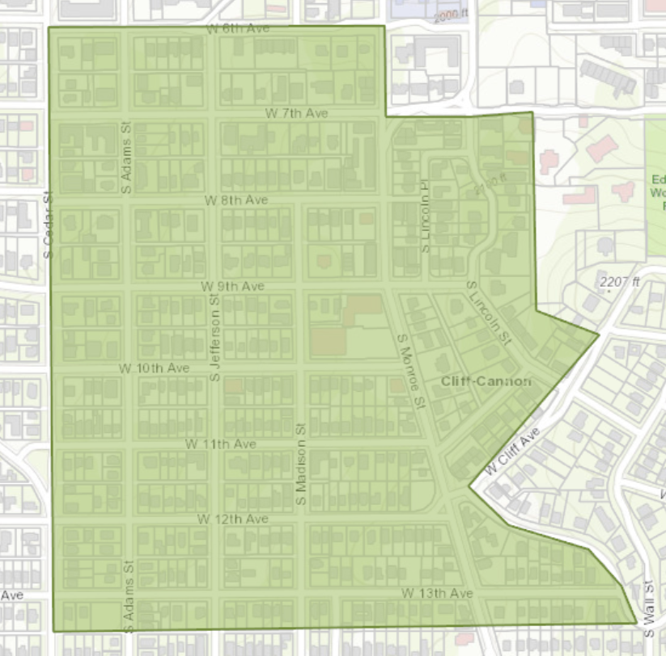

- Logan told the commissioners the Façade Improvement Reimbursement application is now up on the website. There is $15,000 available.
- Jacque West shared information from the Webster Building site visit with the commissioners who did not attend. The commissioners discussed their thoughts on the work already done to the building, whether it is eligible for listing on the Spokane Register of Historic Places, and what to advise the consultant and applicant as to the next steps in the nomination process.
- Chairman’s Report:
- None
- HPO Staff Report:
- None
- Other Announcements:
- None
- The next Hearing is tentatively scheduled for Wednesday, February 19, 2020.

Briefing Session adjourned at 5:03 pm.

